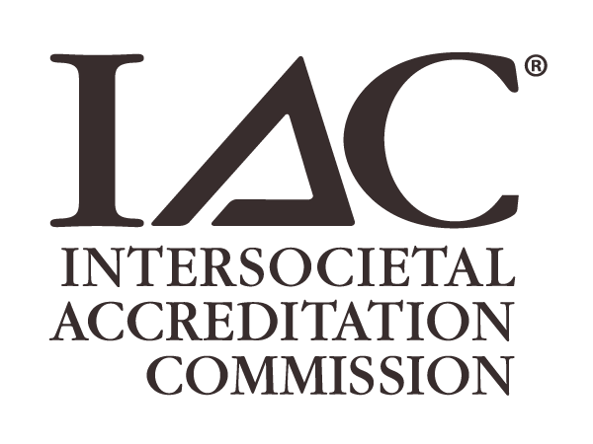

IAC Site Visit Checklist
MRI-Guided Prostate Biopsy Application

Information that will be reviewed during the Site Visit:
Procedure Volumes (estimated annual staff and facility procedure volume information)
Training/Experience and Certificate/Credential Information for Staff (must be kept on file and available for review)
Physicist Surveys (have the annual physicist survey and/or the most recent PM documentation available)
Pre-Procedure Policy: Include the clinical indication/appropriateness, necessity of the prostate biopsy, determination of biopsy technique, confirmation of availability of diagnostic images.
Prior to Performance of Procedure
Include policies for: patient identification, administration of sedation, appropriate supplies availability, patient preparation of the biopsy site.
During the Procedure
Include policies for: patient monitoring during the procedure, sterile technique, anesthesia monitoring, biopsy techniques, determination of target selection/biopsy sites, biopsy sample processing.
Post Procedure, Patient Instructions and Follow Up
Provide policy(ies) to assess the patient’s condition following procedure. This must include: documentation of vital signs, immediate post procedure assessment if general anesthesia was administered, assessment of biopsy site and dressing, management of post-procedure pain, contact information to access the health care team, patient activity restrictions, follow-up appointment, complications assessment, pathology report handling.
Procedure Report: Samples of procedure reports which must include name of the provider(s) performing the procedure, number and location of the biopsy specimens, complications/adverse events, patient condition during and after procedure, sedation information, patient monitoring information.
MRI Equipment Safety Policy: To include patient safety with regard to the MRI environment.
Manufacturer and Physicist Requirements for MRI Safety and Equipment Functionality
Quality Control Program: Must demonstrate installation/acceptance testing, daily and periodic QC testing.
Emergency Equipment/Medication/Supplies: Detailed protocols for routine inspection and quality control checks for emergency medical equipment, supplies and medications that may be used during the procedure.
Emergency Response: Identification of an emergency response cart, resuscitation supplies, equipment, medications, and qualified trained staff (ACLS/BLS)
Quality Improvement Program: Evaluation of QI program to include these QI measures: procedure appropriateness, technical performance of the procedure, patient safety and infection control, procedure outcomes including complications and any adverse events and medical record completeness and timeliness.
Quality Improvement (QI) Meetings: Documentation of two QI meetings per year. Documentation of the meetings must include: every significant complication, all procedures categorized as rarely or never appropriate, review of the data from the required QI measures, educational updates documented and discussed.
Patient Confidentiality Policy: A policy that all facility personnel must ascribe to professional principles of patient confidentiality as legally required by federal, state, local or institutional policy or regulation.
Patient Complaint Policy: A policy that outlines the process for patients to issue a complaint/ grievance in reference to the care/services they received at your facility.
Primary Source Verification Policy: A policy for verifying all medical and technical staff member credentials through the applicable issuing agencies.
Anesthesia Policy: Includes compliance with all federal, state, and local laws and regulations and ASA guidelines where applicable.

 | Helpful Resource – Sample Document Repository  Sample versions of policies and protocols listed above can be found in the IAC Sample Document Repository.

