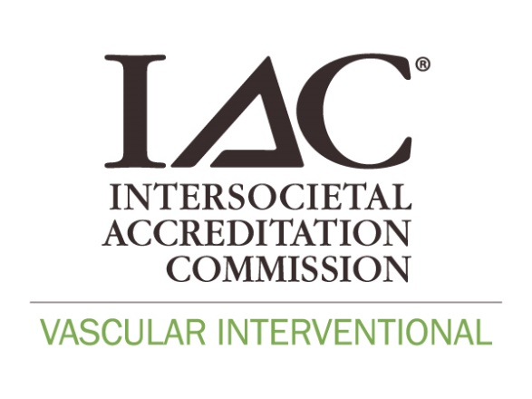

**Case Documentation Checklist**

**Superficial Venous/Vein Center**

|  |  |  |
| --- | --- | --- |
| **Pre-Procedure Documentation**  Complete patient history and physical exam documentation, including, but not limited to:   * History of venous disorders * Past medical history * Family history * Current medications * Allergies * Appropriate clinical indication for the procedure   Noninvasive diagnostic functional reflux ultrasound final report and images (if indicated).  VCSS score (bilateral)  CEAP (bilateral)  QoL measure  Treatment plan | **Procedure**  **Documentation**  Procedure, limb and vessel-specific informed consent  Complete venous procedure summary, including but not limited to:   * Documentation of correct patient, site, and procedure * Anesthesia record * Concentration/amount of tumescent infused * Local anesthetic (if used) * Treatment sites * Start/end time of procedure. * Length of vessel treated. * Catheter insertion site * Energy deposited/RF cycles. * Number of stabs (AP) * Complications or lack thereof * Patient status post procedure | **Post-Procedure Documentation**  Discharge instructions including:   * Procedure performed * Post-procedure care and expectations * Possible adverse events or complications which may require contact with a health care provider * Contact information to access the health care team * Dressing management including compression therapy. * Patient activity, ambulation and exercise * Air and car travel restrictions * Medications * Follow-up appointments   **Follow-Up Documentation**:  Follow-up clinical notes  Follow-up diagnostic ultrasound report |

**Peripheral Arterial/Deep Venous/Hemodialysis Access**

|  |  |  |
| --- | --- | --- |
| **Pre-Procedure Documentation**  Complete patient history and physical exam documentation, including, but not limited to:   * Chief complaint * Past medical history * Family history * Current medications * Allergies * Indication for the procedure * Symptoms and treatment history * Anticoagulation and treatment duration * QoL measure * Treatment plan * CEAP (deep venous) * VCSS (deep venous)   Imaging/consultations  Mallampati (if sedated)  ASA score (if sedated)  Lab studies | **Procedure**  **Documentation**  Procedure specific informed consent  Complete procedure summary, including but not limited to:   * Documentation of correct patient, site, and procedure * Indication for procedure * Description of procedure * Structures imaged. * Operative findings * Treatment performed: success/inadequacy * Complications * Sedation records * Devices used * Documentation of skin preparation and drape * Access site * Medications used * Fluoroscopy exposure * EBL * Contrast type and volume * Patient status at end of procedure * name of person performing procedure * surgical assistant and/or circulator * procedure start and end time * anticoagulation | **Post-Procedure Documentation**  Discharge instructions including:   * Procedure performed * Management of post-procedure pain * Anticoagulation or antiplatelet therapy * Access site, dressings, and wound care * Compression instructions * Bathing instructions * Patient activity * Air and car travel restrictions * adverse events or complications * contact information for health care team. * Follow-up appointments   **Follow-Up Documentation**:  Follow-up clinical notes  Follow-up imaging reports |