TCD: Emboli Detection
____________________________________________________
Transcranial Doppler Monitoring for emboli will be performed using the blind Doppler technique.
A dedicated TCD unit should be used with a 2 MHz pulsed Doppler transducers.
The examination will be explained to the patient.
Patient is supine with head in the neutral position.
The vessel to be insonated for emboli detection will be identified. The middle cerebral artery is the easiest vessel to utilize for this purpose. Either bilateral or unilateral MCA monitoring will be performed depending on the suspected source of emboli. If a central embolic source is suspected (cardiac, A-fib, aortic arch pathology) bilateral monitoring will be performed. If carotid pathology is the suspected source of emboli unilateral monitoring can be performed on the ipsilateral MCA.
As with the diagnostic TCD examination the MCAs will be identified using the transtemporal approach. The MCA is insonated at depths of 45-65 mm for the skin surface. The direction of flow of the MCA in normal pathology will be towards the transducer. The lowest power settings will be used that will provide optimal penetration. Spectral gain will be optimized.
It is easier to identify the optimal temporal acoustic window using the diagnostic 2 MHz transducer first before placing the head band on the patient. This will give you a good idea of where to place the monitoring probe and the best angle to direct the monitoring probe to insonate the MCA for your optimal spectral signal. Some facilities will put a small mark on the patient’s skin after locating the optimal spectral window with the diagnostic probe to help locating the best window with the monitoring probes attached to the head band.
After localizing the optimal temporal acoustic windows, the head band will be placed on the patient with the monitoring probes attached according to the manufacture of the band’s recommendations.
Fig 1. Demonstrating position of head band and monitoring probes.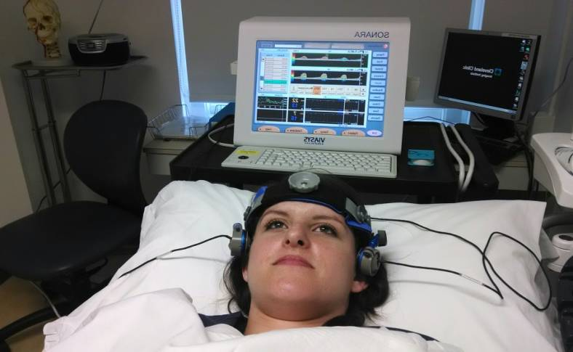
The MCAs will be monitored at the same depth bilaterally for a set amount of time that is established by your institution. If an MCA stenosis is suspected the monitoring depth should be set distal to the stenosis, if possible, to detect emboli.
Routinely the MCAs are monitored for 30 to 60 minutes. Depending on the patient’s clinical presentation, a longer monitoring time may sometimes be required.
The automatic emboli detection software on you unit will be enabled and the entire examination saved on hard drive for review.
All suspected emboli will be recorded for later visual and auditory review. Number of emboli will be counted and documented on the final report. Showers or curtain of emboli will be reported as the duration of the shower measured in seconds. Criteria for the identification of emboli have been established will should be followed. Emboli have characteristic signals. They occur sporadically within the cardiac cycle. They are usually transient (.01 - .1 sec) in duration. They can, however, be seen in showers giving prolonged rough signal similar to artifact. The have intensities which are 3 dB greater than the background Doppler signal. Emboli may have variable signal intensities in the same patient. The sound produced by an embolus is harmonic and described as chirps, whistles or plops.
Consensus committee of the ninth International Cerebral Hemodynamics Symposium. Basic identification criteria of Doppler microembolic signal. Stroke 1995;26:1123
Reporting
The number of embolic events will be reported bilaterally. The mean flow velocity and PI within the insonated depth of the MCA will be reported. An asymmetry >20% within the mean flow velocities or PIs may require a complete TCD diagnostic exam to be performed.
Agitated Saline Protocol – TCD Bubble Study
The TCD bubble study will be performed using the blind Doppler technique.
Dedicated TCD unit will be used with a 2 MHz pulsed Doppler transducer.
Transcranial Doppler is a simple method to detect a right-to-left shunt as a Patent Forman Ovale or pulmonary AVM. Patients with a possible stroke risk factor from a paradoxical embolism can be easily identified by the examination.
The examination is explained to the patient.
Patient is supine with the head in the neutral position.
Optimal MCA spectrums will be obtained using the documented conventional TCD protocol.
The Transcranial Doppler head band will be positioned on the patient using as when doing bilateral TCD monitoring for emboli.
The middle cerebral arteries will be identified bilaterally and monitored continuously during the procedure. Intravenous access will be established by a caregiver trained in venipuncture.
Automated emboli detection software will be enabled, and the entire examination saved on hard drive for review.
Set up for the examination will include:
- Two 10cc syringes
- One three-way stopcock
- 9cc normal saline
Fig 2. Set up for TCD bubble study.
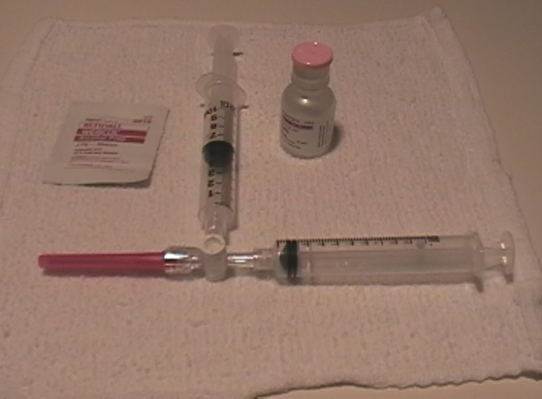
The two 10cc syringes are attached to a three-way stopcock. One syringe is filled with 9cc of normal saline solution. The second syringe is filled with 1cc of air. Using the saline filled syringe, several drops of the patient’s blood will be withdrawn to act as an emulsifier.
The solution will be agitated by withdrawing and injecting between the two syringes with the stopcock turned off to the patient. Once the solution is agitated to satisfaction (usually withdrawing and injecting between the two syringes 10 times). After agitating the saline, the stopcock is turned on to the patient and injected into the venous access of the patient. Immediately after injection the patient is asked to perform a Valsalva maneuver to provoke right-to-left shunting. It helps to explain the Valsalva maneuver to the patient before the procedure to be sure it is done correctly. Any air emboli will be detected and recorded. Emboli will be counted and classified as detected with injection, with Valsalva, or post Valsalva.

