99m-Tc 99mTechnetium-Pyrophosphate
Imaging Protocol for Cardiac Amyloidosis

Indications:
- Evaluation of cardiac involvement in individuals with known or suspected familial amyloidosis
- Diagnosis of cardiac ATTR amyloidosis in individuals with CMR or echocardiography consistent with cardiac amyloidosis.
- Patients with suspected cardiac ATTR amyloidosis and contraindications to CMR such as renal insufficiency or an implantable cardiac device

Contraindications:
There are no contraindications.

Patient preparation:
No preparation is required.

Radiopharmaceutical: (intravenous injection)
Tc-99m pyrophosphate (99mTc-PYP)- 10-20 mCi
*** In the event there is a shortage of PYP, alternative radiopharmaceuticals may be used***
Tc-99m hydroxymethylene diphosphonate (99mTc-HMDP)- 10-20 mCi

Injection to Imaging time:
2-3 hours post injection of radiopharmaceutical for both Planar and SPECT imaging

Patient Positioning:
Supine with arms above head
Orientation- Head in

Camera set up:
- Collimator (All): Low energy, high resolution (LEHR)
- Energy window: 140 keV (20% window)
- Detector Configuration 90˚ for Planar and SPECT
- Non-gated imaging
- Pixel size 3.5-6.5 mm

Planar Imaging:
- Static acquisitions- 750K counts/image.
- Views: anterior, L lateral, and LAO (anterior and L lateral can be acquired
- Simultaneously with 90˚ detector configuration)
- Magnification 1.46
- Matrix 256 x 256

SPECT imaging:
- Angular range: 180˚
- Number of views/detectors: 40
- Time per stop: 20 seconds
- Orbit: Non-circular
- Matrix: 128 x 128
- Zoom: 1.46

Acquisition Procedure:
Planar Imaging
Acquire planar images as described above in Anterior, Left Lateral, and LAO views 2-3 hours post injection of radiopharmaceutical.

SPECT Imaging
SPECT imaging will be performed as described above immediately following 3 view planar imaging. SPECT acquisition time is approximately 14-15 minutes, and the patient is encouraged to hold still.

Processing Procedure:
Planar Imaging
  - Using static display take “snapshots” or “screen saves” all static images.
  - Labeled with correct view and time of acquisition.
  - Draw a circular ROI over the heart on the 2–3-hour planar images.
  - This region will be the “H” (heart) region. This region should not include bone uptake.
  - Careful to use the exact same ROI, place the ROI over the contralateral lung.
  - This region will be the “CL” (background) region.
  - Note the meaning counts for each ROI.
  - Calculate H/CL ratio, as follows:
    - (Mean Heart Counts) ÷ (Mean Contralateral Lung Counts)
  - Additional Information to note/label for each ROI: Maximum Counts /pixel, Standard Deviation, Total counts, Area size of ROI (to assure size of both heart and background ROIs are as close to the same size as possible)

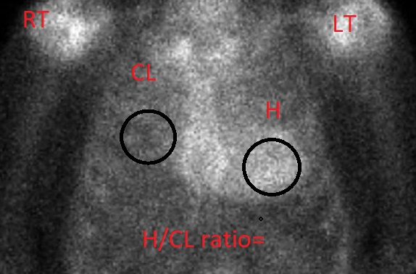

SPECT Imaging

- SPECT imaging can be processed according to the patient’s heart-to-contralateral lung (H/CL) ratio.
  - Ratio <1.5 process as a bone/chest SPECT study with little or no cardiac uptake
  - Ratio >/= 1.5 process as an MPI study because of significant cardiac uptake
****Iterative reconstruction, Butterworth Filter, 0.5/6****
- Click on the Reconstruction tab.
- Reconstruction limits and orientation are automatically determined. Review and align/adjust as necessary.
- Center the images
- Adjust crosshairs so that they intersect with the center of the heart.
- Click on Display
- Check images correct display of short, vertical long, and horizontal long axis.
- Select the complete button.
- Cardiac Reconstruction images are complete.
- Save
- Send to PACS system for physician review.

